1. Create a scale set with windows OS

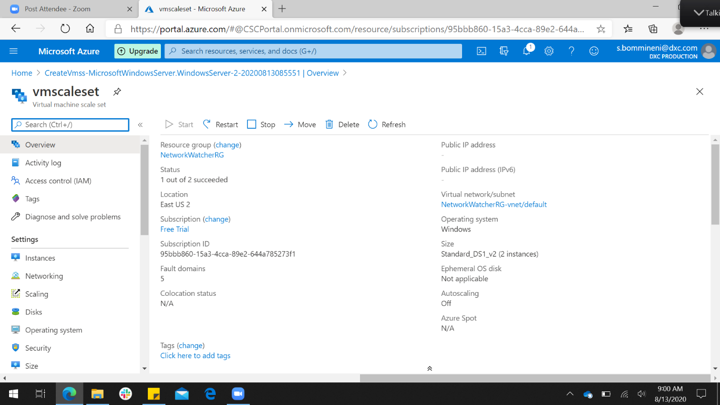

2) write scale out rule using CPU percentage of 70% threshold

3) write scale in rule using CPU percentage of 40% threshold

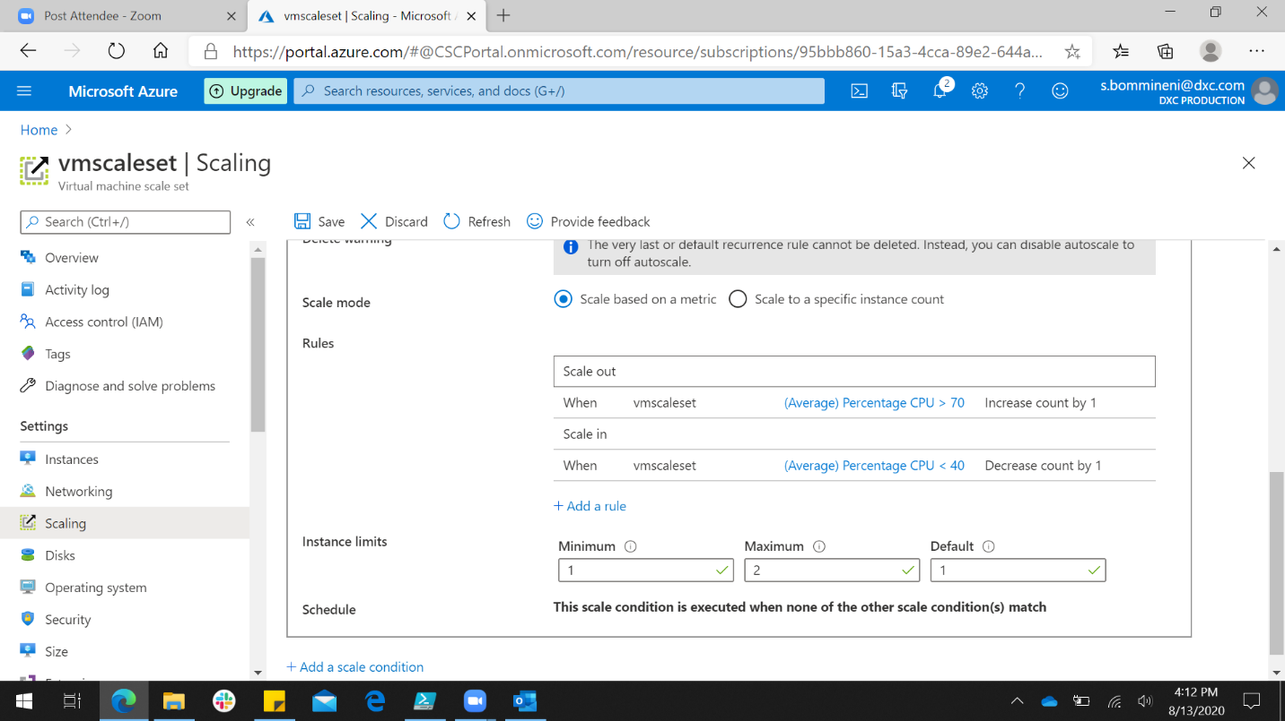

4) Create an storage account and containers with anonyms access, create a static website in the storage account

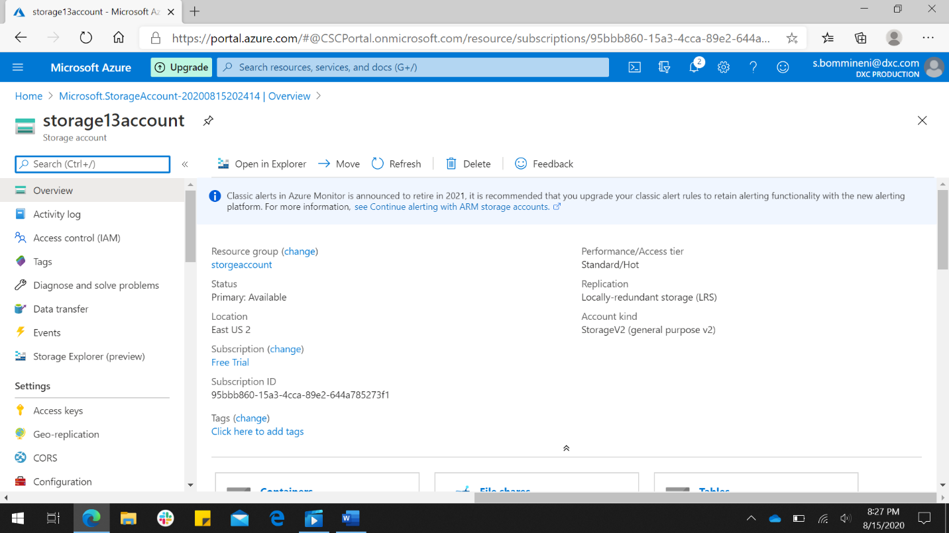

Storage account is created.

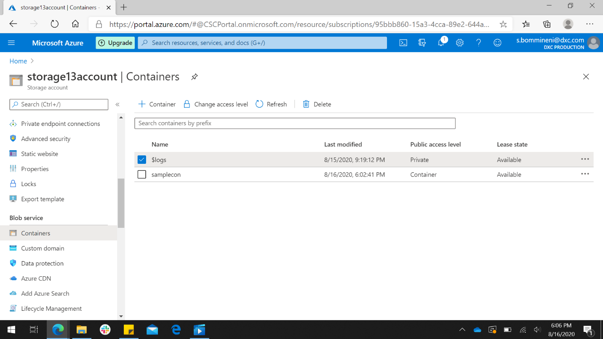

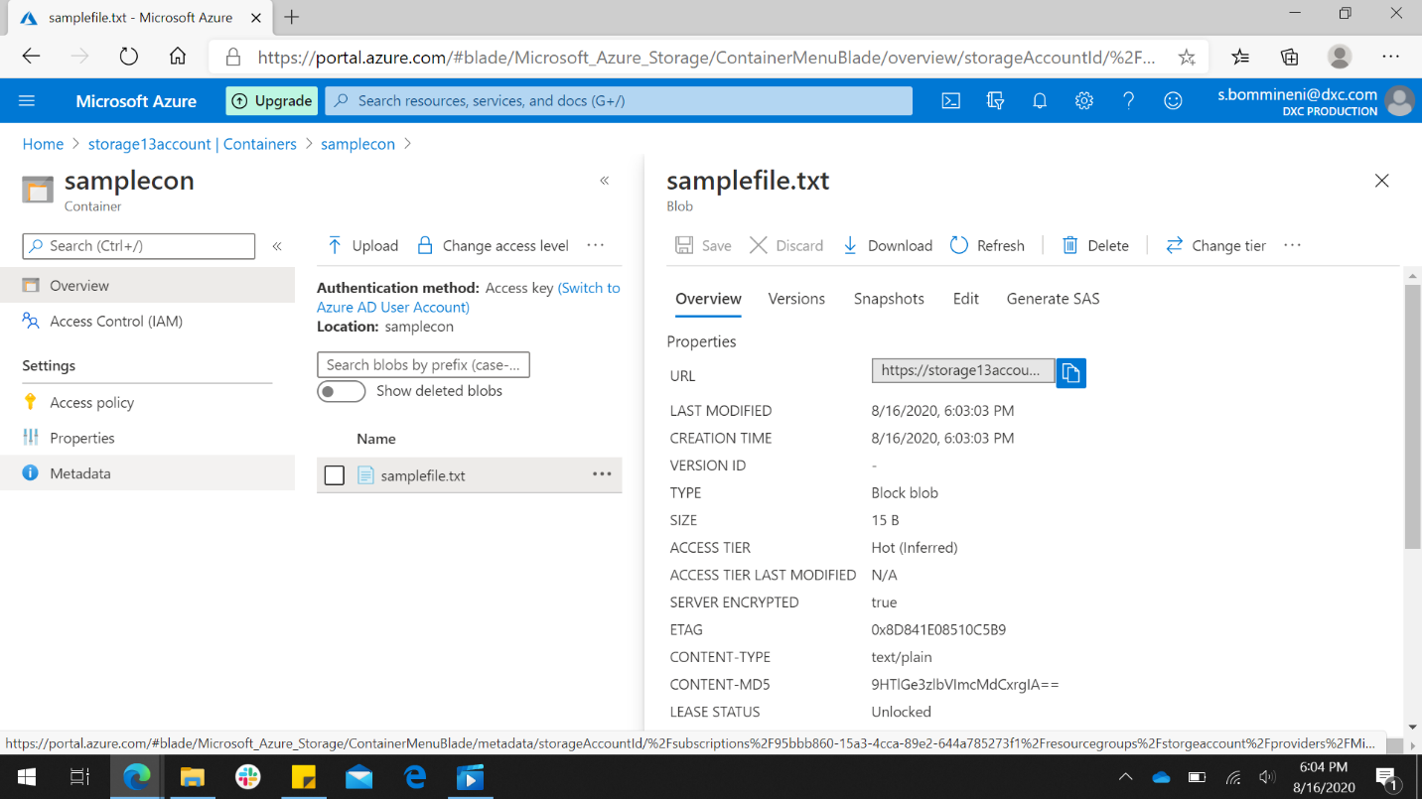

Created anonyms accessed container.

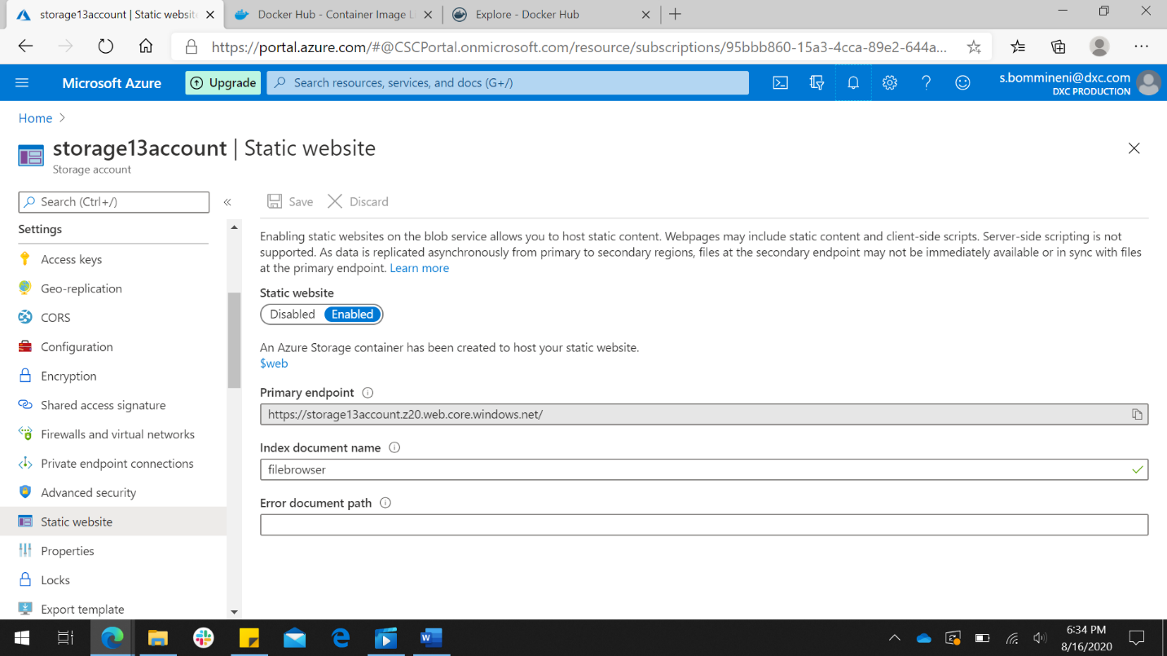

Created static website.

5) Create two virtual machine with no public ip’s

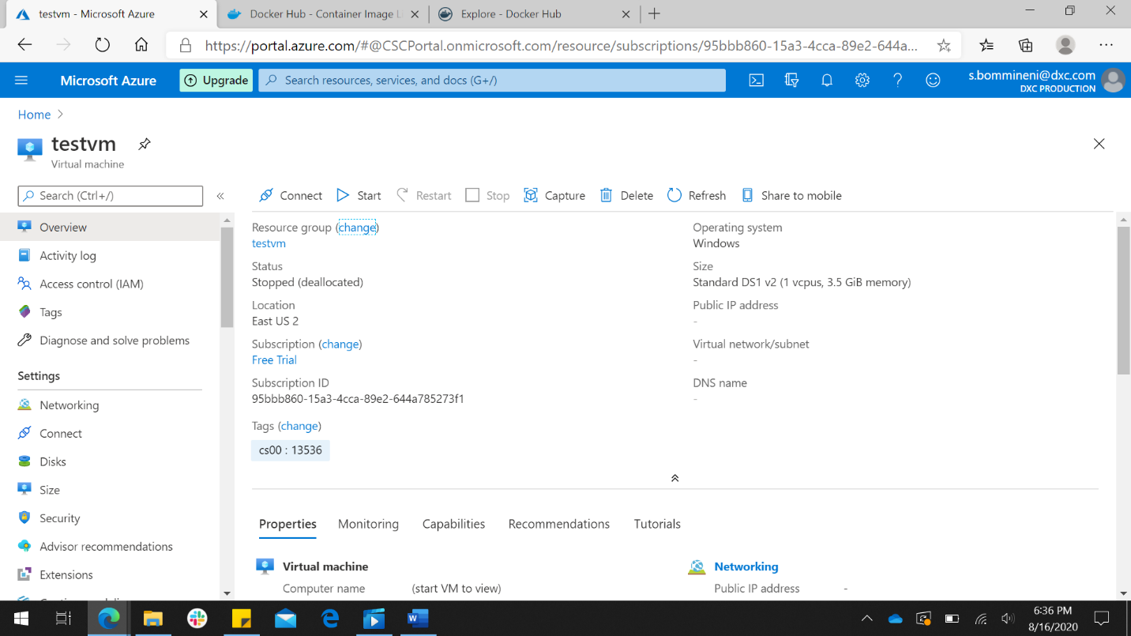

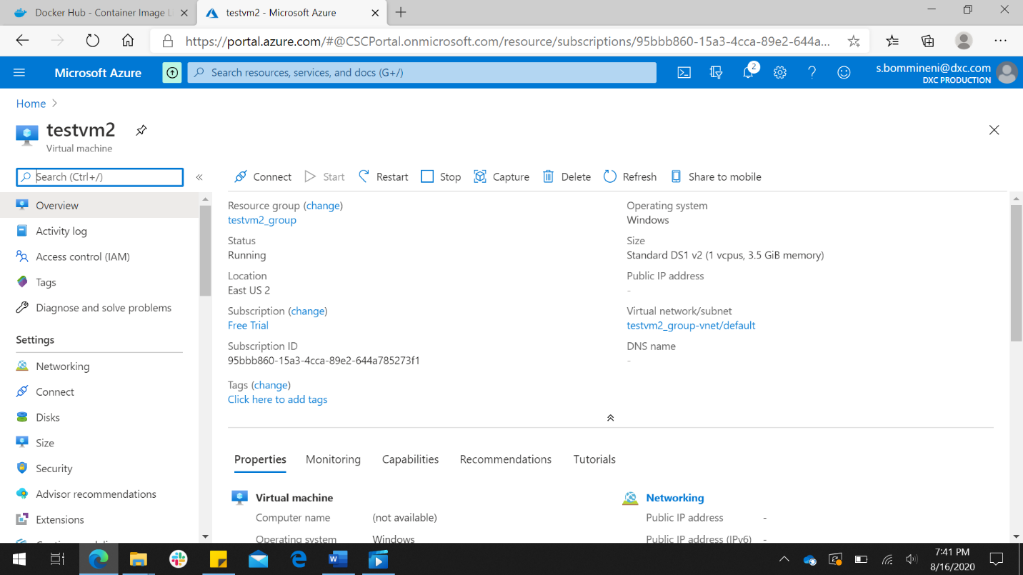

6) Attach the machine to the load balancer and block the 3389 port use 50010

